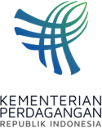 | PRESS RELEASE  Public Relations Bureau  Bldg. I Fl. 2, Jl. M.I. Ridwan Rais No. 5, Jakarta 10110 Phone: 021-3860371/Fax: 021-3508711  www.kemendag.go.id

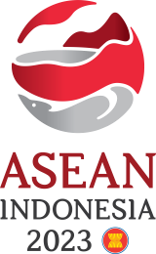
The 20th AEM-India Consultation Meeting,

Minister of Trade Zulkifli Hasan: ASEAN Optimizing the AIFTA Agreement
Semarang, 21 August 2023 – ASEAN and India agreed to optimize the use of the ASEAN-India Free Trade Area/AIFTA, including reducing existing trade barriers. This was conveyed by the Minister of Trade, Zulkifli Hasan, after chairing the 20th ASEAN Economic Minister (AEM)-India Consultation Meeting on Monday (21/8), in Semarang, Central Java. The Indian delegation was led by the Secretary of the Department of Commerce of the Indian Ministry of Trade and Industry Rajesh Agrawal.

"The 20th AEM-India consultation meeting is the 12th meeting in the series meetings of the 55th AEM meetings. The meeting ratified three documents, namely, the framework for the joint committee on the ASEAN-India Trade in Goods/AITIGA, the AITIGA work plan review, and the review negotiating structure of the AITIGA," said Trade Minister Zulkifli Hasan.

Trade Minister Zulkifli Hasan continued, in order to support the agreement, AEM has assigned the negotiating team to continue discussing the AITIGA review. The goal is that AITIGA can become a more facilitative and profitable agreement for businesses.

Trade Minister Zulkifli Hasan also revealed that the meeting supports the priorities and programs of ASEAN-India Business Council/AIBC. For example, those related to reducing trade barriers (quotas and technical standards) and financial facilitation support.

Meanwhile, in his opening remarks, Trade Minister Zulkifli Hasan said that currently India is ASEAN's 7th largest trade partner while ASEAN is India's 4th largest trade partner. "Therefore, this meeting is an important momentum to strengthen trade relations between ASEAN and India, as well as to gain support for Indonesia as the ASEAN Chair this year," added Trade Minister Zulkifli Hasan.

The total trade between ASEAN and India in 2022 amounted to USD 113 billion, an increase of
23.4 percent from the previous year. From the investment side, inflows of foreign direct investment (FDI) from India to ASEAN reached USD 681 million in 2022.

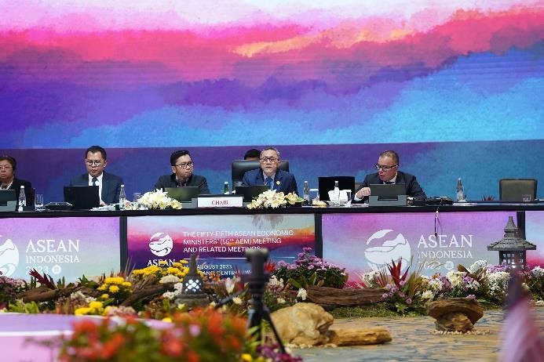 | 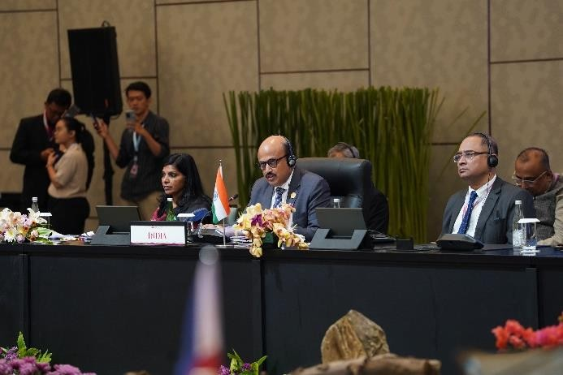

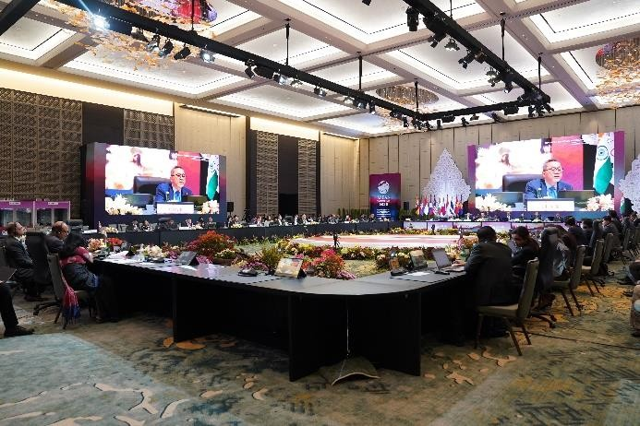 | 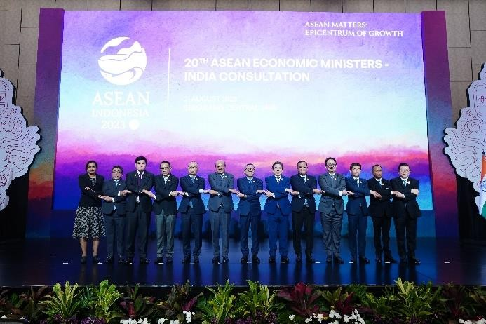

--end--

For further information please contact:  Ani Mulyati  Head of Public Relations Bureau Ministry of Trade  Email: pusathumas@kemendag.go.id | Dina Kurniasari  Director of ASEAN Negotiations  Directorate General of International Trade Negotiations Ministry of Trade  Email: asean@kemendag.go.id

